1. Given the provided data, what are three conclusions we can draw about Kickstarter campaigns?

From the “Campaigns by status” pivot table (screenshot provided below), we can conclude that almost 53% of the projects were successful and 47% of the projects were failed, cancelled, and live. The theater and music projects make up the most of these successful projects and constitutes 63% of successful projects.

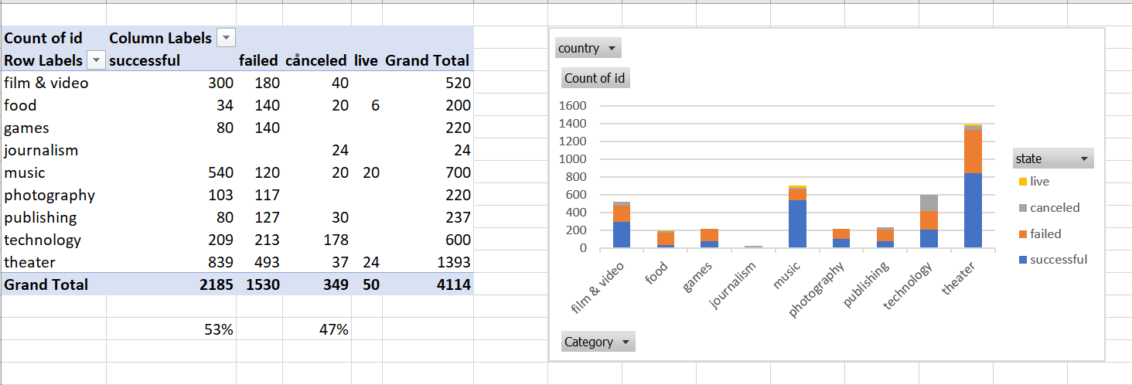

The theater and music projects make up the most of these successful projects and constitutes 63% of successful projects shown in the graph below.

From the “Campaigns by subcategory” pivot table (screenshot provided below), we can conclude the “plays” has 62.11% success rate and most successful within the theater category. Every category of music was 100% successful, except for indie rock, with 94.5% success rate. The least successful projects were technology’s wearable subcategory with 7% success rate.

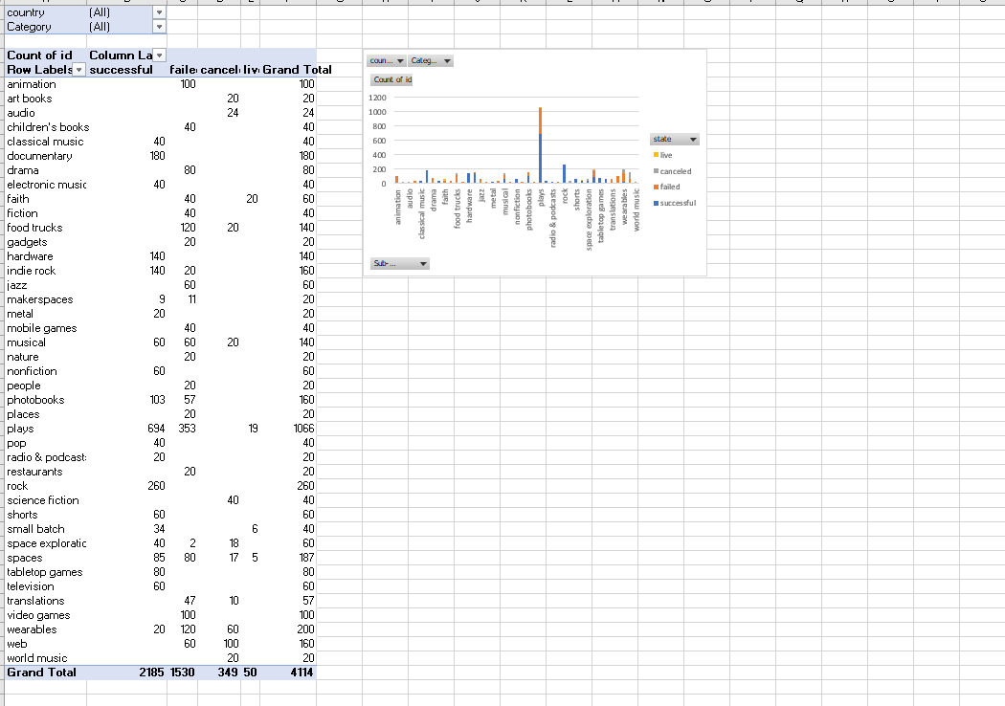

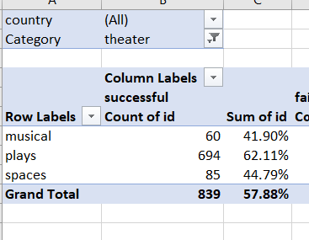 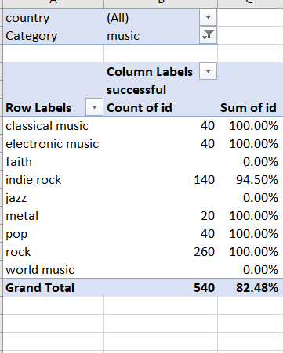

The third conclusion we can draw from “Campaigns by launch month” (screenshot show below) is that projects that launched May have the highest chance of success and projects that started in December have the highest rate failure. Since May is the most successful month, projects may want to launch in May vs. December.

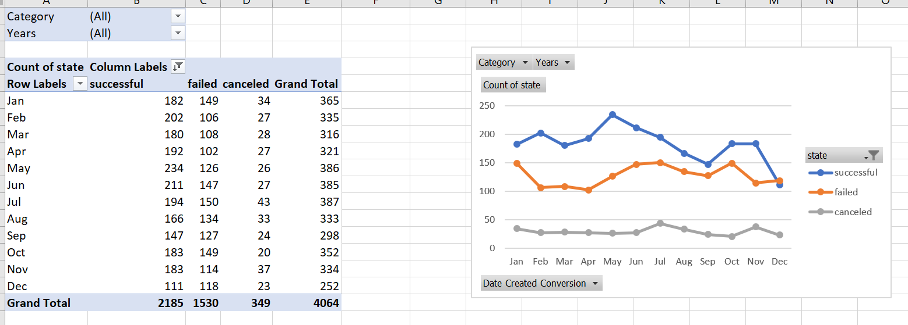

1. What are some limitations of this dataset?

* We believe that the successful projects data is skewed to the right because, the normal population success rate is 1/3 per the sentence given “only a third have made it through the funding process with a positive outcome.” The conclusion 1 above reveals that 54% of the projects were successful. Therefore, it could be that data collected may not be representative of the population.
* The data could be incomplete for the live projects since there were no results/state reported for the live projects (only March to May of 2017 data was provided for live projects).
* Data integrity - If these data come from surveys, people may not have provided accurate information. Also, data collected from different sources can vary in quality and format.
* The data may not comparable because it is represented in different currencies.

1. What are some other possible tables and/or graphs that we could create?

We can create many pivot tables and graphs using recommended charts in excel. There are: pie chart, stacked bar, scatter with smooth lines and markers, histogram and radar etc.) The some of them are shown in the excel homework submission and screenshots are shown in the questions 1 and 2.